<country>
<language of test>
STUDENT Questionnaire

School Name
Student ID
Student Name
Family Name
Given Name
Date of Birth
/ / 198
Day
Month
Year
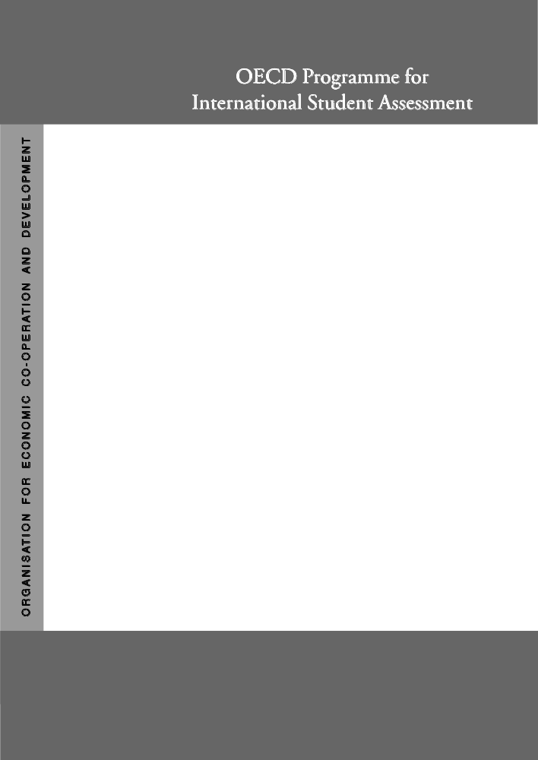

Project Consortium:
Australian Council for Educational Research (ACER)
Netherlands National Institute for Educational Measurement (CITO)
Educational Testing Service (ETS, USA)
National Institute for Educational Research (NIER, Japan)
Westat (USA)

In this booklet you will find questions about:
- you and your family;
- your experience of your school;
- what you plan to do in the future.
Please read each question carefully and answer as accurately as you can. In the test you usually circled your answers. For the questionnaire, you will normally answer by <ticking> a box. For a few questions you will need to write in a short answer.
If you make a mistake when <ticking> a box, cross out your error and mark the correct box. If you make an error when writing in an answer, simply cross it out and write the correct answer next to it.
In this questionnaire, there are no ‘right’ or ‘wrong’ answers. Your answers should be the ones that are ‘right’ for you.
You may ask for help if you do not understand something or are not sure how to answer a question.
Your answers will be kept confidential. Thank you.

ST01Q01  ST01Q02  ST01Q03 | Q 1 On what date were you born?  (Please write in the day, month and year you were born.)  <_____ ___________ 198 ___>  Day Month Year

ST02Q01 | Q 2 What <grade> are you in? _______ <grade>

ST03Q01 | Q 3 Are you <female> or <male>? <Female> <Male>  ₁ ₂

ST04Q01  ST04Q02  ST04Q03  ST04Q04  ST04Q05  ST04Q06  ST04Q07  ST04Q08 | Q 4 Who usually lives at <home> with you?  (Please <tick>only one box on each row.)  Yes No  a) Mother ₁ ₂  b) Other female guardian (e.g., stepmother or foster mother) ₁ ₂  c) Father ₁ ₂  d) Other male guardian (e.g., stepfather or foster father) ₁ ₂  e) Brother(s) (including stepbrothers) ₁ ₂  f) Sister(s) (including stepsisters) ₁ ₂  g) Grandparent(s) ₁ ₂  h) Others ₁ ₂

ST05Q01  ST05Q02  ST05Q03 | Q 5 How many brothers and sisters do you have?  (Please <tick> only one box on each row. When appropriate, remember to <tick> the ‘None’ box.)  Four or  None One Two Three more  a) Older than you     ₅  b) Younger than you     ₅  c) Same age as you     ₅

Some of the following questions are about your mother and father (or those person(s) who are like a mother or father to you — for example, guardians, step-parents, foster parents, etc.).
If you share your time with more than one set of parents or guardians, please answer the following questions for those parents/step-parents/guardians you spend the most time with.

ST06Q01 | Q 6 What is your mother currently doing?  (Please <tick> only one box.)  Working full-time <for pay> ₁  Working part-time <for pay> ₂  Not working, but looking for a job ₃  Other (e.g. home duties, retired) ₄

ST07Q01 | Q 7 What is your father currently doing?  (Please <tick> only one box.)  Working full-time <for pay> ₁  Working part-time <for pay> ₂  Not working, but looking for a job ₃  Other (e.g. home duties, retired) ₄

Q 8 What is your mother’s main job? (e.g., <School teacher, nurse, sales manager>)
If she is not working now, please tell us her last main job.
Please write in the job title.

ST09Q01 | Q 9 What does your mother do in her main job? (e.g., <Teaches high school students, cares for patients, manages a sales team>)  If she is not working now, please tell us her last main job.  Please use a sentence to describe the kind of work she does or did in that job.

Q 10 What is your father’s main job? (e.g., <School teacher, carpenter, sales manager>)
If he is not working now, please tell us his last main job.
Please write in the job title.

ST11Q01 | Q 11 What does your father do in his main job? (e.g., <Teaches high school students, builds houses, manages a sales team>)  If he is not working now, please tell us his last main job.  Please use a sentence to describe the kind of work he does or did in that job.

ST12Q01 | Q 12 Did your mother complete <ISCED 3A>?  (Please <tick> only one box.)  No, she did not go to school ₁  No, she completed <ISCED level 1> only ₂  No, she completed <ISCED level 2> only ₃  No, she completed <ISCED level 3B or 3C> only ₄  Yes, she completed <ISCED level 3A> ₅

ST13Q01 | Q 13 Did your father complete <ISCED 3A>?  (Please <tick> only one box.)  No, he did not go to school ₁  No, he completed <ISCED level 1> only ₂  No, he completed <ISCED level 2> only ₃  No, he completed <ISCED level 3B or 3C> only ₄  Yes, he completed <ISCED level 3A> ₅

ST14Q01 | Q 14 Did your mother complete <ISCED 5A, 5B, 6>?  (Please <tick> only one box.)  Yes No  ₁ ₂

ST15Q01 | Q 15 Did your father complete <ISCED 5A, 5B, 6>?  (Please <tick> only one box.)  Yes No  ₁ ₂

ST16Q01  ST16Q02  ST16Q03 | Q 16 In what country were you and your parents born?  (Please <tick> only one box on each row.)  <Country Another  of test> Country  a) You ₁ ₂  b) Mother ₁ ₂  c) Father ₁ ₂

ST17Q01 | Q 17 What language do you speak at home most of the time?  (Please <tick> only one box.)  <Test language> ₁  <Other official national languages> ₂  <Other national dialects or languages> ₃  <Other languages> ₄

ST18Q01  ST18Q02  ST18Q03  ST18Q04  ST18Q05  ST18Q06 | Q 18 During the past year, how often have you participated in these activities?  (Please <tick> only one box on each row.)  About  Never Once 3 or 4 More than  or hardly or twice times 4 times  ever a year a year a year  a) Gone to the <pictures>. ₁ ₂ ₃ ₄  b) Visited a museum or art gallery. ₁ ₂ ₃ ₄  c) Attended a popular music concert. ₁ ₂ ₃ ₄  d) Attended an opera, ballet or  classical symphony concert. ₁ ₂ ₃ ₄  e) Watched live theatre. . ₁ ₂ ₃ ₄  f) Attended sporting events. ₁ ₂ ₃ ₄

ST19Q01  ST19Q02  ST19Q03  ST19Q04  ST19Q05  ST19Q06 | Q 19 In general, how often do your parents:  (Please <tick> only one box on each row.)  Never A few About Several Several  or hardly times once a times a times a  ever a year month month week  a) discuss political or social issues with you? ₁ ₂ ₃ ₄ ₅  b) discuss books, films or television  programmes with you? ₁ ₂ ₃ ₄ ₅  c) listen to classical music with you? ₁ ₂ ₃ ₄ ₅  d) discuss how well you are doing at school? ₁ ₂ ₃ ₄ ₅  e) eat <the main meal> with you around  a table? ₁ ₂ ₃ ₄ ₅  f) spend time just talking to you? ₁ ₂ ₃ ₄ ₅

ST20Q01  ST20Q02  ST20Q03  ST20Q04  ST20Q05  ST20Q06 | Q 20 How often do the following people work with you on your <schoolwork>?  (Please <tick> only one box on each row.)  Never A few About Several Several  or hardly times once a times a times a  ever a year month month week  a) Your mother ₁ ₂ ₃ ₄ ₅  b) Your father ₁ ₂ ₃ ₄ ₅  c) Your brothers and sisters ₁ ₂ ₃ ₄ ₅  d) Grandparents ₁ ₂ ₃ ₄ ₅  e) Other relations ₁ ₂ ₃ ₄ ₅  f) Friends of your parents ₁ ₂ ₃ ₄ ₅

ST21Q01  ST21Q02  ST21Q03  ST21Q04  ST21Q05  ST21Q06  ST21Q07  ST21Q08  ST21Q09  ST21Q10  ST21Q12 | Q 21 In your home, do you have:  (Please <tick> only one box on each row.)  Yes No  a) a dishwasher? ₁ ₂  b) a room of your own? ₁ ₂  c) educational software? ₁ ₂  d) a link to the Internet? ₁ ₂  e) a dictionary? ₁ ₂  f) a quiet place to study? ₁ ₂  g) a desk for study? ₁ ₂  h) text books? ₁ ₂  i) classic literature (e.g., <Shakespeare>)? ₁ ₂  j) books of poetry? ₁ ₂  k) works of art (e.g., paintings)? ₁ ₂

ST22Q01  ST22Q02  ST22Q03  ST22Q04  ST22Q05  ST22Q06  ST22Q07 | Q 22 How many of these do you have at your home?  (Please <tick> only one box on each row.)  Three or  None One Two more  a) <Cellular> phone    ₄  b) Television    ₄  c) Calculator    ₄  d) Computer    ₄  e) Musical instrument (e.g., piano, violin)    ₄  f) Motor car    ₄  g) Bathroom    ₄

ST23Q01  ST23Q02  ST23Q03  ST23Q04 | Q 23 During the last three years, have you attended any of these special courses at your school to improve your results?  (Please <tick> only one box on each row.)  No, Yes, Yes,  never sometimes regularly  a) <Extension> or additional courses ₁ ₂ ₃  b) <Remedial> courses in <test language> ₁ ₂ ₃  c) <Remedial> courses in other subjects ₁ ₂ ₃  d) Training to improve your study skills ₁ ₂ ₃

ST24Q01  ST24Q02  ST24Q03  ST24Q04  ST24Q05  ST24Q06  ST24Q07 | Q 24 During the last three years, have you attended any of these special courses outside of your school to improve your results?  (Please <tick> only one box on each row.)  No, Yes, Yes,  never sometimes regularly  a) courses in <test language> ₁ ₂ ₃  b) courses in other subjects ₁ ₂ ₃  c) <Extension> or additional courses ₁ ₂ ₃  d) <Remedial> courses in <test language> ₁ ₂ ₃  e) <Remedial> courses in other subjects ₁ ₂ ₃  f) Training to improve your study skills ₁ ₂ ₃  g) <Private tutoring> ₁ ₂ ₃

ST25Q01 | Q 25 What <programme> are you in at school?  (Please <tick> only one box.)  <ISCED 2A> ₁  <ISCED 2B> ₂  <ISCED 2C> ₃  <ISCED 3A> ₄  <ISCED 3B> ₅  <ISCED 3C> ₆

ST26Q01  ST26Q02  ST26Q03  ST24Q04  ST24Q05  ST24Q06  ST24Q07  ST24Q08  ST24Q09  ST24Q10  ST24Q11  ST24Q12  ST24Q13  ST24Q14  ST24Q15  ST24Q16  ST24Q17 | Q 26 How often do these things happen in your <test language> lessons?  (Please <tick> only one box on each row.)  Some Most Every  Never lessons lessons lesson  - The teacher has to wait a long time for  students to <quieten down> ₁ ₂ ₃ ₄  - The teacher wants students to work hard ₁ ₂ ₃ ₄  - The teacher tells students that they  can do better ₁ ₂ ₃ ₄  - The teacher does not like it when students  deliver <careless> work ₁ ₂ ₃ ₄  - The teacher shows an interest in every  student’s learning ₁ ₂ ₃ ₄  - The teacher gives students an opportunity  to express opinions ₁ ₂ ₃ ₄  - The teacher helps students with their work ₁ ₂ ₃ ₄  - The teacher continues teaching until  the students understand ₁ ₂ ₃ ₄  - The teacher does a lot to help students ₁ ₂ ₃ ₄  - The teacher helps students with their learning ₁ ₂ ₃ ₄  - The teacher checks students’ homework ₁ ₂ ₃ ₄  - Students cannot work well ₁ ₂ ₃ ₄  - Students don’t listen to what the teacher says ₁ ₂ ₃ ₄  - Students don’t start working for a long time  after the lesson begins ₁ ₂ ₃ ₄  - Students have to learn a lot ₁ ₂ ₃ ₄  - There is noise and disorder ₁ ₂ ₃ ₄  - At the start of class, more than five minutes are  spent doing nothing ₁ ₂ ₃ ₄

ST27Q01  ST27Q02  ST27Q03  ST27Q04  ST27Q05  ST27Q06 | Q 27 In the last full week you were in school, how many <class periods> did you spend in:  (Please write in the number of class periods.)  Does this number apply for  Total number most of the school year?  a) <test language>? _________ Yes ₁ No ₂  b) <mathematics> <in total>? _________ Yes ₁ No ₂  c) <science> <in total>? _________ Yes ₁ No ₂

ST27Q01  ST27Q02  ST27Q03 | Q 28 On average, about how many students are in your:  (Please write in the average number of students in each class.)  Average number  a) <test language class(es)>? . __________  b) <mathematics class(es)>? __________  c) <science class(es)>? __________

ST28Q01  ST28Q02  ST28Q03 | Q 29 How many times in the previous two school weeks did you:  (Please <tick> only one box on each row.)  5  None 1 or 2 3 or 4 or more  a) miss school? .    ₄  b) <skip> classes?    ₄  c) arrive late for school?    ₄

ST30Q01  ST30Q02  ST30Q03  ST30Q04  ST30Q05 | Q 30 How much do you disagree or agree with each of the following statements about teachers at your school?  (Please <tick> only one box on each row.)  Strongly Strongly  disagree Disagree Agree agree  a) Students get along well with most teachers ₁ ₂ ₃ ₄  b) Most teachers are interested  in students’ well-being ₁ ₂ ₃ ₄  c) Most of my teachers really listen  to what I have to say ₁ ₂ ₃ ₄  d) If I need extra help, I will receive it from  my teachers ₁ ₂ ₃ ₄  e) Most of my teachers treat me fairly ₁ ₂ ₃ ₄

ST31Q01  ST31Q02  ST31Q03  ST31Q04  ST31Q05  ST31Q06  ST31Q07  ST31Q08 | Q 31 My school is a place where:  (Please <tick> only one box on each row.)  Strongly Strongly  disagree Disagree Agree agree  a) I feel like an outsider (or left out of things). . ₁ ₂ ₃ ₄  b) I make friends easily. . ₁ ₂ ₃ ₄  c) I feel like I belong. ₁ ₂ ₃ ₄  d) I feel awkward and out of place. ₁ ₂ ₃ ₄  e) other students seem to like me. ₁ ₂ ₃ ₄  f) I feel lonely. . ₁ ₂ ₃ ₄  g) I do not want to go. . ₁ ₂ ₃ ₄  h) I often feel bored. ₁ ₂ ₃ ₄

ST32Q01  ST32Q02  ST32Q03  ST32Q04  ST32Q05  ST32Q06  ST32Q07 | Q 32 Please indicate how often each of these applies to you.  (Please <tick> only one box on each row.)  Some- Most of  Never times the time Always  a) I complete my homework on time ₁ ₂ ₃ ₄  b) I do my homework while watching television ₁ ₂ ₃ ₄  c) My teachers grade my homework ₁ ₂ ₃ ₄  d) I finish my homework during  the school day ₁ ₂ ₃  ₄  e) My teachers make useful comments on  my homework ₁ ₂ ₃  ₄  f) I am given interesting homework ₁ ₂ ₃  ₄  g) My homework is counted as part of  my <marks> ₁ ₂ ₃ ₄

ST33Q01  ST33Q02  ST33Q03 | Q 33 On average, how much time do you spend each week on homework and study in these subject areas?  (Please <tick> only one box on each row.)  When answering include time at the weekend too.  Between 3 hours  No Less than 1 and or  time 1 hour 3 hours more  a week a week a week  a) <test language> ₁ ₂ ₃ ₄  b) <mathematics> ₁ ₂ ₃ ₄  c) <science> ₁ ₂ ₃ ₄

ST34Q01 | Q 34 Each day, about how much time do you usually spend reading for enjoyment?  (Please <tick> only one box.)  I do not read for enjoyment ₁  30 minutes or less each day ₂  More than 30 minutes to less than 60 minutes each day ₃  1 to 2 hours each day ₄  More than 2 hours each day ₅

ST35Q01  ST35Q02  ST35Q03  ST35Q04  ST35Q05  ST35Q06  ST35Q07  ST35Q06  ST35Q07 | Q 35 How much do you disagree or agree with these statements about reading?  (Please <tick> only one box on each row.)  Strongly Strongly  disagree Disagree Agree agree  a) I read only if I have to ₁ ₂ ₃ ₄  b) Reading is one of my favourite hobbies ₁ ₂ ₃ ₄  c) I like talking about books with other people ₁ ₂ ₃ ₄  d) I find it hard to finish books ₁ ₂ ₃ ₄  e) I feel happy if I receive a book as a present ₁ ₂ ₃ ₄  f) For me, reading is a waste of time ₁ ₂ ₃ ₄  g) I enjoy going to a bookstore or a library ₁ ₂ ₃ ₄  h) I read only to get information that I need ₁ ₂ ₃ ₄  i) I cannot sit still and read for more than  a few minutes ₁ ₂ ₃ ₄

ST36Q01  ST36Q02  ST36Q03  ST36Q04  ST36Q05  ST36Q06 | Q 36 How often do you read these materials because you want to?  (Please <tick> only one box on each row.)  Never A few About Several Several  or hardly times once a times a times a  ever a year month month week  a) Magazines ₁ ₂ ₃ ₄  ₅  b) Comic books ₁ ₂ ₃ ₄  ₅  c) Fictions (novels, narratives, stories) ₁ ₂ ₃ ₄ ₅  d) Non-fiction books ₁ ₂ ₃ ₄ ₅  e) Emails and Web pages ₁ ₂ ₃ ₄ ₅  f) Newspapers ₁ ₂ ₃ ₄ ₅

ST | Q 37 How many books are there in your home?  There are usually about <40 books per metre> of shelving. Do not include magazines.  (Please <tick> only one box.)  None ₁  1-10 books ₂  11-50 books ₃  51-100 books ₄  101-250 books ₅  251-500 books ₆  More than 500 books ₇

ST38Q01 | Q 38 How often do you borrow books to read for pleasure from a public or school library?  (Please <tick> only one box.)  Never or hardly ever ₁  A few times per year ₂  About once a month ₃  Several times a month ₄

ST39Q01  ST39Q02  ST39Q03  ST39Q04  ST39Q05 | Q 39 At your school, about how often do you use:  (Please <tick> only one box on each row.)  Never A few About Several Several  or hardly times once a times a times a  ever a year month month week  - school library? ₁ ₂ ₃ ₄ ₅  - computers? ₁ ₂ ₃ ₄ ₅  - calculators? ₁ ₂ ₃ ₄ ₅  - Internet? ₁ ₂ ₃ ₄ ₅  - <science> laboratories? ₁ ₂ ₃ ₄ ₅

ST40Q01 | Q 40 What kind of job do you expect to have when you are about 30 years old?  Write the job title:

ST41Q01  ST41Q02  ST41Q03  ST41Q04  ST41Q05  ST41Q06 | Q 41 In your last school report, what <mark> did you receive in the following subjects?  a) <Test language> _______  b) <Mathematics> _______  c) <Science> _______  Q 41 In your last school report, how did your <mark> compare with the <pass mark> in each subject area?  (Please <tick> only one box on each row.)  Above the At the Below the  <pass mark> <pass mark> <pass mark>  a) <Test language> ₁ ₂ ₃  b) <Mathematics> ₁ ₂ ₃  c) <Science> ₁ ₂ ₃
Thank you for completing this questionnaire

